Myles J Sartor
Matthew Griffin
STAT100-0121
26 September 2023
Problem Set 3
1a-1b.:
.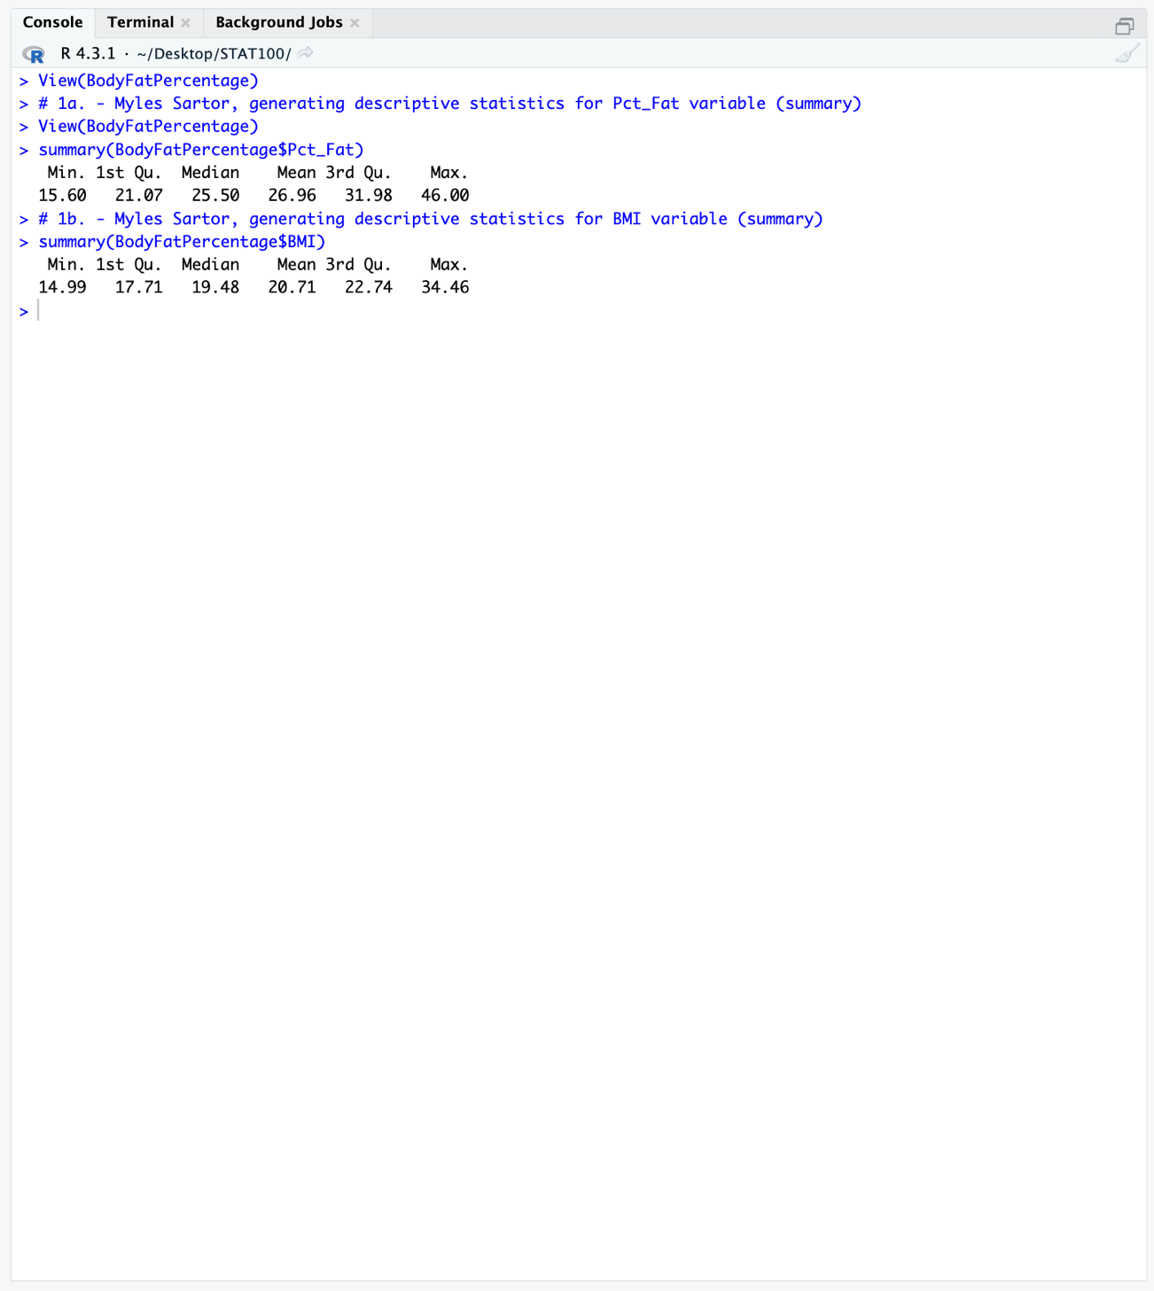
1c. Upper Fence: 31.98 + 1.5(31.98 – 21.07) = 48.345
Lower Fence: 21.07 – 1.5(31.98 – 21.07) = 4.705
No, 6.0 % wouldn’t be considered an outlier since the lower fence is 4.705 %, and 6.0 % is greater than this, meaning 4.705 % would fall within the range of values possible for the IQR criteria.
1d. Upper Fence: 22.74 + 1.5(22.74 – 17.71) = 30.285
Lower Fence: 17.71 – 1.5(22.74 – 17.71) = 10.165
Yes, 32 would be considered an outlier since the upper fence is 30.285, and 32 is greater than this, meaning 30.285 wouldn’t fall within the range of values possible for the IQR criteria.
2a.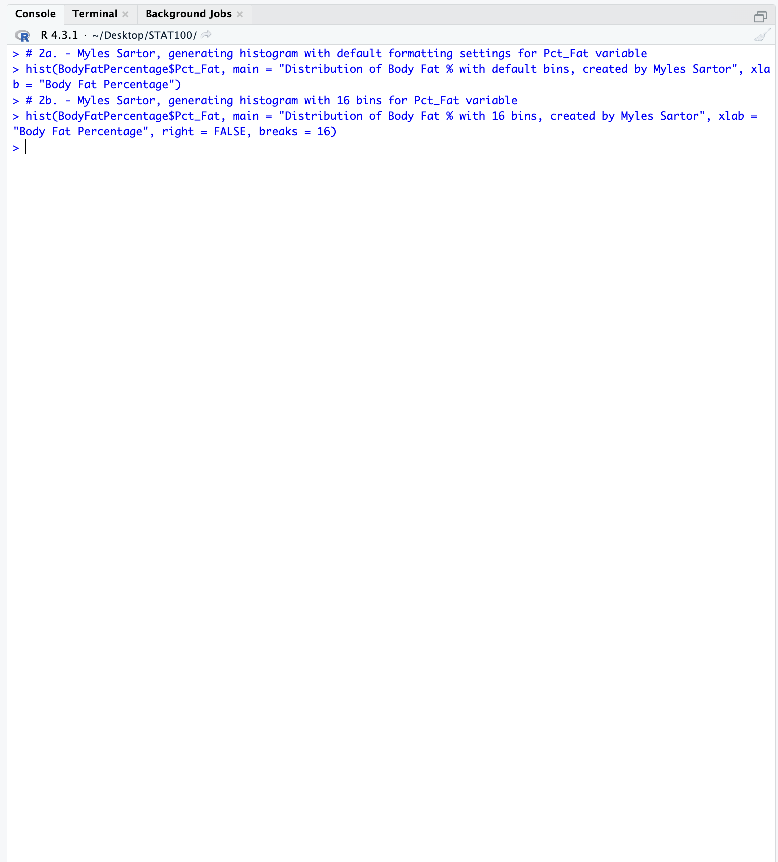
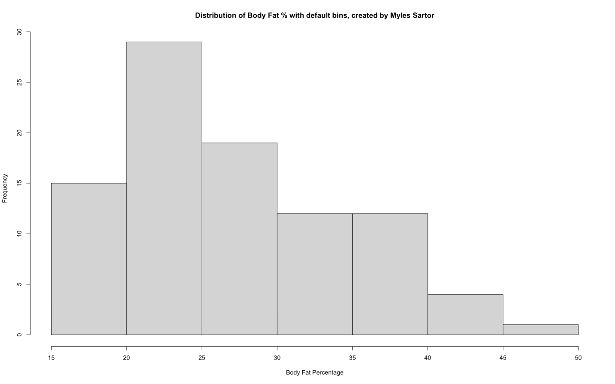
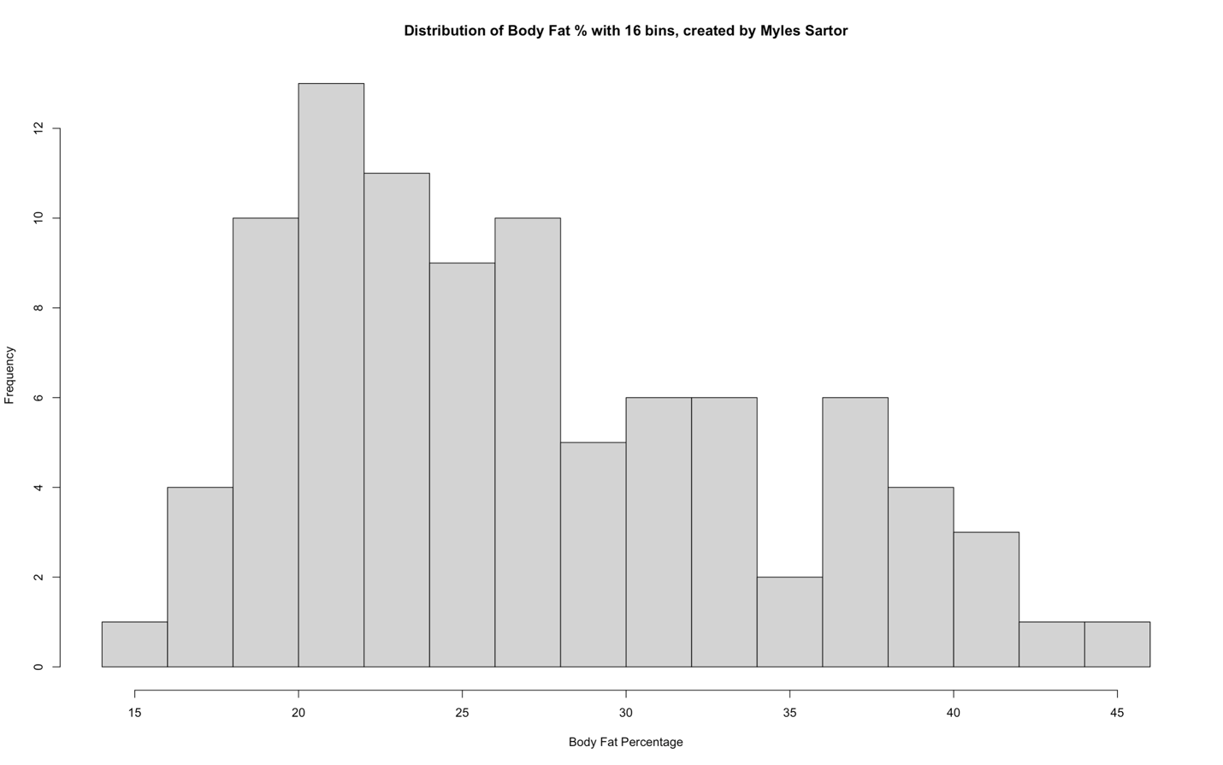
2b. The body fat histogram with the default number of bins is skewed slightly to the right, as the tail on the right is a bit longer. In addition, its center lies between the 25-30 interval, as this is the interval that has the median of the data set (46th and 47th observations of the 92). Since the data is only “slightly” skewed in its distribution, it is safe to assume that the mode, median, and mean are all around the same value near the peak frequency (25-26ish). The mode typically resides at the highest peak of the histogram (most frequency), so this specifically would fall between 20-25. The mean would then be slightly greater than the median (right skew), around 26-27 (Can check by dividing the sum of values by the number of observations). The data is spread out pretty well until it reaches boy fat percentages of 40 toward the end (50). Here, we are met with two intervals that introduce the small possibility of outliers since their frequencies are so low. However, there is no clear breakaway from the rest of the data set, so there would only be a small number of outliers in the 45-50 interval. The maximum value the histogram takes into account is 50 and the minimum value is 15 (Range: 50 – 15 = 35). When using the histogram with 16 bins, the distribution still mainly has a right skewed tail that is simply longer now. In addition, the center is still in the same interval area (25-30, 1st bar) since the median hasn’t changed, it just shows up under a different amount of bars. Even though the tallest interval has a much smaller frequency than before, the mode and mean that come out of this show up in the same interval spots too (20-25). The spread of this histogram is relatively the same despite the greater number of bars that are depicted across the entire range (45-15 = 30, Max -- min). The outliers for this histogram also still exist at the end of the distribution (40-45ish). There are low-frequency areas at 35 and 15.
2c. Using the default formatting histogram, the median body fat percentage falls between the 25-30 interval as this is the interval where the 46th and 47th observations of the 92-observation data set exist. I divided 92 (the total number of observations) by 2 to get 46 (an even number). Since this number was even, I had to include the next number in the data set in my approximation for the mean by looking at the histogram. I counted until I got to the interval that had the 46th and then the 47th frequency count, which was the 25-30 interval (1st interval: 15, 2nd interval: 28, 3rd interval: 19, first two only add up to 43, so the third must have 46 and 47.
2d.
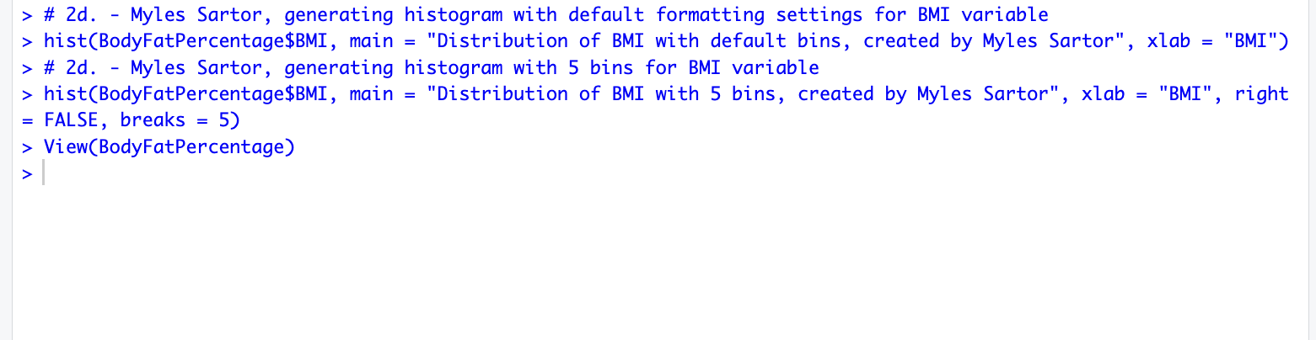
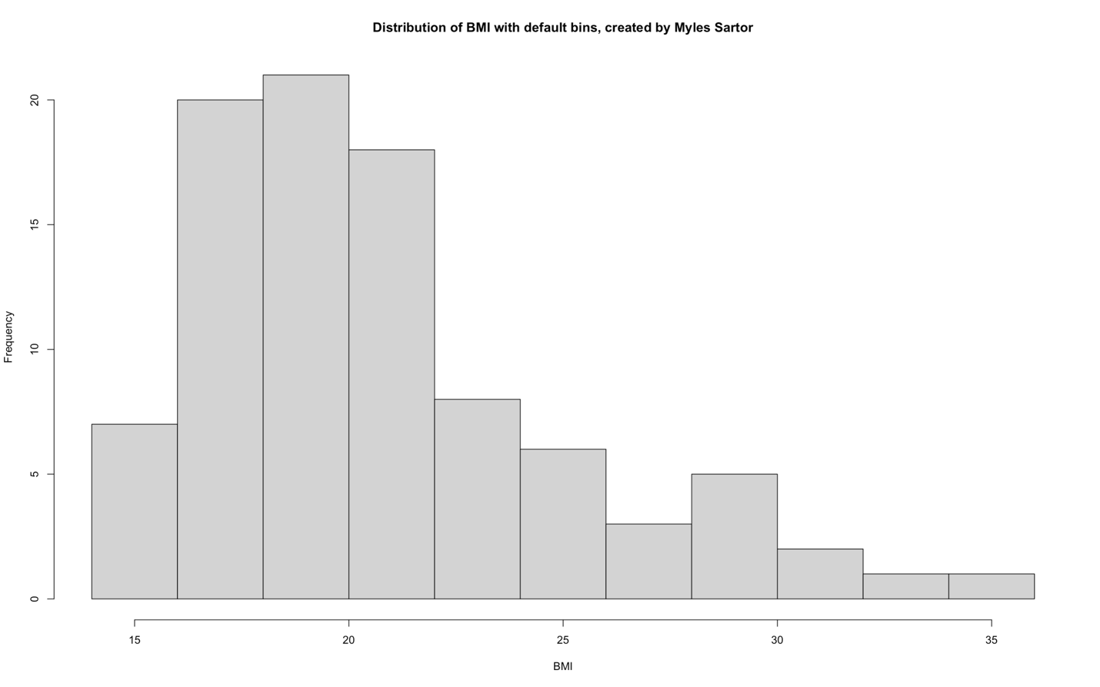
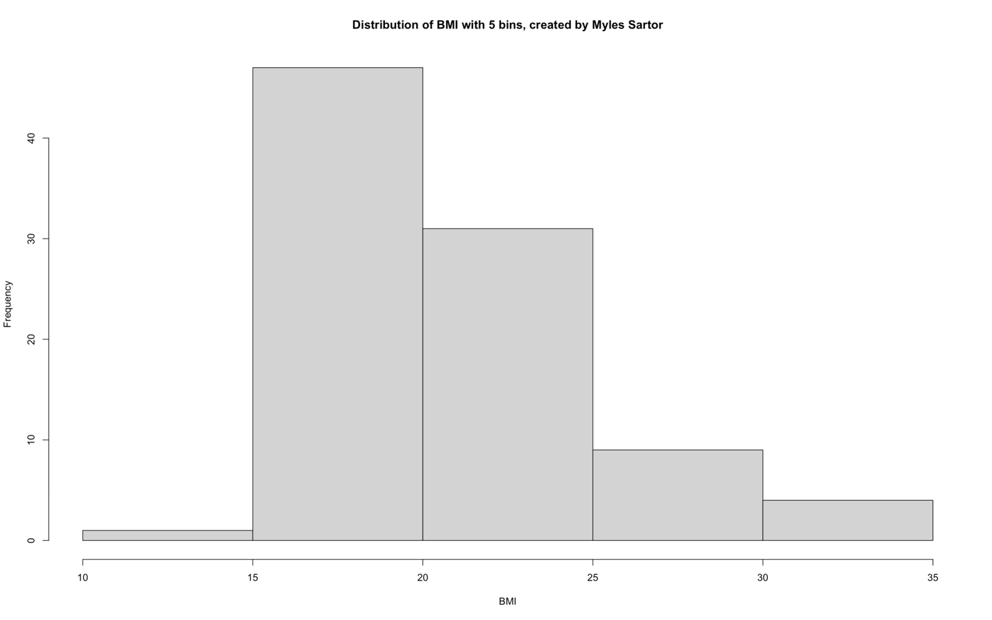
2e. The distribution of the default formatting BMI histogram is right-skewed with a lot of bars along the right tail. The center of the histogram is in the 15-20 interval (3rd bar), as this is where the median resides (as well as the mode and almost the mean). The highest frequency is near this center area within the same interval (20ish). The spread of this histogram spans a bit far, with the range being 35-15 = 20 (Max – min). The only real outlier potential lies after the interval including 30 and up to around 35, as this is where the data begins to branch off from the other parts of the histogram. There is a random low frequency point in the 25-30 interval. The distribution of the 5-bin BMI histogram is still right-skewed, but with a much shorter right tail to show for it. The center interval of the histogram lies in the same area as the highest frequency or mode (15-20), and this is also where the median will reside. The mean won’t be that far off this interval if we were to calculate it (slightly greater since it’s right skewed). The spread of this histogram includes a range of 35 – 10 = 25 (Max – min), and the same outlier potential as last time (30-35 interval at the end of the histogram). Since this histogram includes the space of BMI from 10-15, there also appears to be more outlier potential here. The 10-15 interval, 25-30, and 30-35 interval are the only areas with lower-valued frequencies. Only one new outlier area (10-15), was added by looking at this new 5 bin histogram.
2f. Using the 5-bin histogram, the median falls between the 15-20 histogram interval, as this is the area in which the 46th and 47th observations of the data set reside. I added up the frequencies of the 10-15 interval and 15-20 interval to get my answer (3 + 46 = 49). It was a 92-observation data set, divided by 2, giving me 46, and then 47 to check for.

